CORDOVA PUBLIC COLLEGE

COLLEGE OF COMPUTER STUDIES

**Software Design Description**

*for*

Campus Communication Web Platform

Documentation for Capstone Project

Jezrael Suliano

Arnel L. Carcela

Jhon Richard Bensi

# **Table of Contents**

# **List of Figures**

# **List of Table**

Contents

**1.** **Table of Contents** 2

**2.** **List of Figures** 3

**3.** **List of Table** 4

4. Introduction 5

**4.1.** **Introduction** 5

**4.2.** **Scope** 5

**5.** **Decomposition Description** 6

**5.1.** **Module Decomposition** 6

**5.2.** **Data Decomposition** 6

**6.** **Interface Description** 7

**6.1.** **Module Interface** 7

**7.** **Detailed Design** 8

**7.1.** **Module Detailed Design** 8

8. 9

**8.1.** **Module Interface** 9

1. Introduction

## **Introduction**

The software Design Description outlines the software design and providing clear overview of how each page and components functions. This document provide a comprehensive view of how the system will be built and how it will meet its objectives and expectations.

## **Scope**

The scope of this document covers the design of Campus Communication web platform, it outlines the design and user interface.

# **Decomposition Description**

## **Module Decomposition**

Module 1. User Log in

The usage of this page is to allow user to log into the web with exclusive functions.

Module 2. Registration

This usage of page is to allow user to create account to access the campus communication web platform

Module 3. Home page

In this page this makes the user access exclusive functions and features.

Module 4. Profile page

In this page this allow user to create a profile of their account

Module 5. Groups and Department

In this function you can access the page of your department, you can also access multiple department page base on your course.

Module 6. Message

This allow user to communicate each other with real time messaging.

Module 7. Notifications

This makes user allow to be notify that a certain event and announcement is made by chairperson and dean.

Module 8. School Map

This feature have a clear view of a selected school.

Module 9. Newsfeed

This allow user to interact to a various post, comment , and images posted by everyone.

Module 10. Admin

This interface can interact in admin side of the system where administrator can see the basic info of student and teacher, can also can access the pendings profile and post.

## **Data Decomposition**

5.2.1 Register Entity Description

| Attribute Name | Attribute Type | Attribute Size |
| --- | --- | --- |
| **user_id** | int | 11 |
| **name** | text | 100 |
| **username** | text | 100 |
| **password** | varchar | 100 |
| **user_type** | text | 100 |
| **dep_type** | text | 100 |
| **isdeleted** | int | 11 |
| **date_created** | date |  |
| **status** | int | 11 |
| **counterlock** | int | 11 |

5.2.2 Users Entity Description

| Attribute Name | Attribute Type | Attribute Size |
| --- | --- | --- |
| **id** | int | 11 |
| **uid** | int | 100 |
| **school_id** | int | 100 |
| **fullname** | varchar | 100 |
| **email** | varchar | 100 |
| **address** | varchar | 100 |
| **number** | int | 11 |
| **yr_sec** | varchar | 100 |
| **acadyr** | varchar | 11 |
| **role_in_school** | varchar | 11 |
| **department** | varchar | 100 |
| **pic** | text | 100 |
| **cover** | text | 100 |
| **date_registered** | date |  |
| **status** | varchar | 100 |
| **approval** | varchar | 100 |

5.2.3 Post Entity Description

| Attribute Name | Attribute Type | Attribute Size |
| --- | --- | --- |
| **post_id** | int | 11 |
| **user_id** | int | 11 |
| **names** | text | 100 |
| **description** | text | 100 |
| **image** | text | 100 |
| **date_created** | datetime |  |
| **isdeleted** | int | 11 |
| **isapprove** | int | 11 |

5.2.4 Comment Entity Description

| Attribute Name | Attribute Type | Attribute Size |
| --- | --- | --- |
| **comment_id** | int | 11 |
| **pos_id** | int | 11 |
| **user_id** | int | 11 |
| **uname** | text | 100 |
| **comment** | text | 100 |
| **date** | datetime |  |
| **isapprove** | int | 11 |

5.2.5 Report Entity Description

| Attribute Name | Attribute Type | Attribute Size |
| --- | --- | --- |
| **report_id** | int | 11 |
| **post_id** | int | 11 |
| **report_type** | tex | 100 |
| **date_reported** | date |  |

5.2.6 Announcement Entity Description

| Attribute Name | Attribute Type | Attribute Size |
| --- | --- | --- |
| **a_id** | int | 11 |
| **title** | text | 100 |
| **description** | tex | 100 |
| **date_created** | date |  |

5.2.7 Events Entity Description

| Attribute Name | Attribute Type | Attribute Size |
| --- | --- | --- |
| **events_id** | int | 11 |
| **title** | text | 100 |
| **date** | date |  |
| **event** | tex | 100 |
| **date_posted** | date |  |

5.2.8 Message Entity Description

| Attribute Name | Attribute Type | Attribute Size |
| --- | --- | --- |
| **id** | int | 11 |
| **incoming_id** | int | 11 |
| **outgoing_id** | int | 11 |
| **messages** | varchar | 299 |
| **date_send** | timestamp |  |

# **Interface Description**

## **Module Interface**

Module 1. User Log in

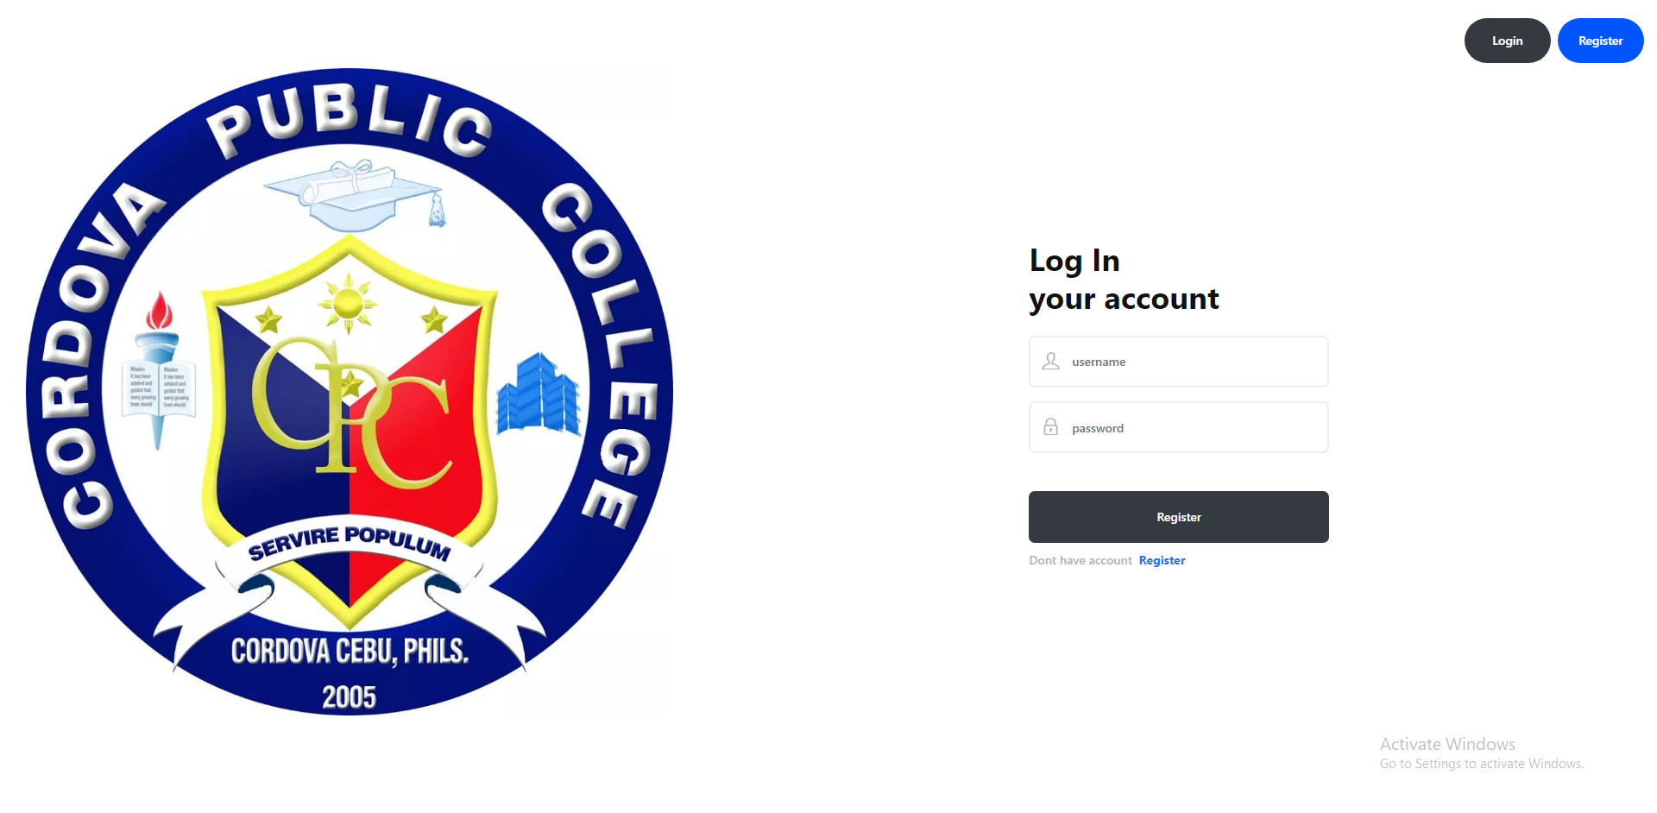

Module 2. Registration

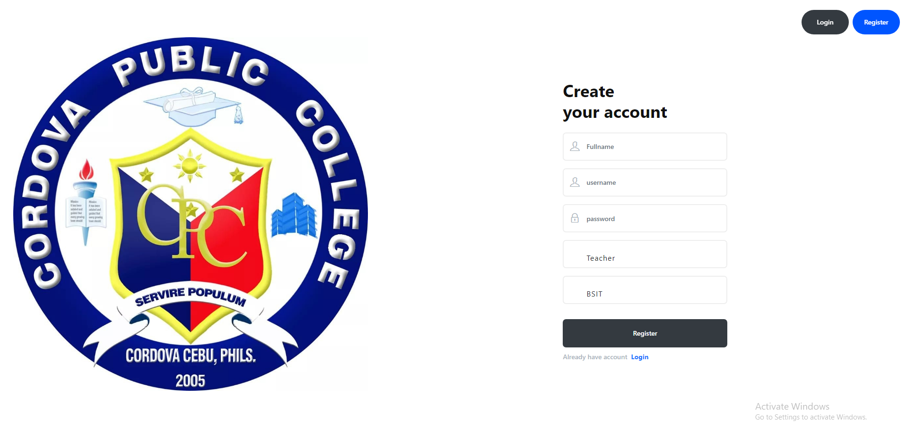

Module 3. Home page

Module 4. Profile page

Module 5. Groups and Department

Module 6. Message

Module 7. Notifications

Module 8. School Map

Module 9. Newsfeed

# **Detailed Design**

## **Module Detailed Design**

Module 1. User Log in

Pre-condition: Connect to sign-in.php

Module Name: Sign In

Type: Webpage

Description: This module is gateway to the system

Button Name: Sign In

Flow: Enter the username and password,

click the Sign In button.

Module 2. Registration

Pre-condition: Connect to sign-up.php

Module Name: Sign Up

Type: Webpage

Description: This module is to register user

Button Name: Register

Flow: Enter the your information specified in input field,

Click the register button,

Click the Sign in button to redirect in Sign IN page

Module 3. Home page

Pre-condition: Connect to teacherhome.php/studenthome.php/alumni.php

Module Name: Homepage

Type: Webpage

Description: This module Explore each exclusive Functions

Button Name: Profile, Newsfeed, Department, Message, School Map, Log out, Post, Comment, Report, Announcement, Events

Flow: Click profile to view profile page,

Click newsfeed to view content,

Click Department to view department content,

Click Message to interact other user,

Click School Map to view school ground,

click Post to create post,

Click comment to comment on post,

Click report to report post,

Click Announcement to create and see Announcement,

Click Events to create and see events

Module 4. Profile page

Pre-condition: Connect to profile.php

Module Name: Profile Information

Type: Webpage

Description: This module is to create Profile information

Button Name: Create Profile

Flow: Input Information specified in Input fields

Click Create

Module 5. Groups and Department

Pre-condition: Connect to Department.php

Module Name: department (Name)

Type: Webpage

Description: This module Explore each exclusive Functions

Button Name: Profile, Newsfeed, Department, Message, School Map, Log out, Post, Comment, Report, Announcement, Events

Flow: Click profile to view profile page,

Click newsfeed to view content,

Click Department to view department content,

Click Message to interact other user,

Click School Map to view school ground,

click Post to create post,

Click comment to comment on post,

Click report to report post,

Click Announcement to create and see Announcement,

Click Events to create and see events

Module 6. Message

Pre-condition: connect to chat.php

Module Name: Messenger

Type: Webpage

Description: this module interact other users

Button Name: Send message, other users

Flow: input message in textarea

Click Send Button

Click other user Button

Module 7. Notifications

Pre-condition: connect notification dropdown

Module Name: Notification

Type: Webpage

Description: this module shows Notification

Button Name: Notification bell

Flow: Click notification bell

Module 8. School Map

Pre-condition: connect to schoolmap.php

Module Name: School Map

Type: Webpage

Description: this module shows School Map

Button Name:

Flow: it shows school ground

Module 8. Admin(dashboard)

Pre-condition: connect to dashboard.php

Module Name: School Map

Type: Webpage

Description: this module shows count of teacher and student

Button Name: users, reports, pending,

Flow: it shows school ground

# 

## **Module Interface**